**Convolutional Network in TensorFlow**

It's time to walk through an example Convolutional Neural Network (CNN) in TensorFlow.

The structure of this network follows the classic structure of CNNs, which is a mix of convolutional layers and max pooling, followed by fully-connected layers.

The code you'll be looking at is similar to what you saw in the segment on [**Deep Neural Network in TensorFlow**](https://classroom.udacity.com/nanodegrees/nd009/parts/c983b707-8f75-4c5e-8567-7134e21e5a65/modules/24611a52-b490-497c-aaba-47db1f4ef3fd/lessons/cb4ae92e-abf2-49c9-afae-e497dd25f3fb/concepts/43664323-f76e-4b3d-8cde-5ad0c8345d1c), except we restructured the architecture of this network as a CNN.

Just like in that segment, here you'll study the line-by-line breakdown of the code. If you want, you can even [**download the code**](https://d17h27t6h515a5.cloudfront.net/topher/2017/February/58a61ca1_cnn/cnn.zip) and run it yourself.

Thanks to [**Aymeric Damien**](https://github.com/aymericdamien/TensorFlow-Examples) for providing the original TensorFlow model on which this segment is based.

Time to dive in!

**Dataset**

You've seen this section of code from previous lessons. Here we're importing the MNIST dataset and using a convenient TensorFlow function to batch, scale, and One-Hot encode the data.

**from** tensorflow.examples.tutorials.mnist **import** input_data

mnist = input_data.read_data_sets(".", one_hot=**True**, reshape=**False**)

**import** tensorflow **as** tf

*# Parameters*

learning_rate = 0.00001

epochs = 10

batch_size = 128

*# Number of samples to calculate validation and accuracy*

*# Decrease this if you're running out of memory to calculate accuracy*

test_valid_size = 256

*# Network Parameters*

n_classes = 10 *# MNIST total classes (0-9 digits)*

dropout = 0.75 *# Dropout, probability to keep units*

**Weights and Biases**

*# Store layers weight & bias*

weights = {

'wc1': tf.Variable(tf.random_normal([5, 5, 1, 32])),

'wc2': tf.Variable(tf.random_normal([5, 5, 32, 64])),

'wd1': tf.Variable(tf.random_normal([7*7*64, 1024])),

'out': tf.Variable(tf.random_normal([1024, n_classes]))}

biases = {

'bc1': tf.Variable(tf.random_normal([32])),

'bc2': tf.Variable(tf.random_normal([64])),

'bd1': tf.Variable(tf.random_normal([1024])),

'out': tf.Variable(tf.random_normal([n_classes]))}

**Convolutions**



Convolution with 3×3 Filter. Source: [**http://deeplearning.stanford.edu/wiki/index.php/Feature_extraction_using_convolution**](http://deeplearning.stanford.edu/wiki/index.php/Feature_extraction_using_convolution)

The above is an example of a [**convolution**](https://en.wikipedia.org/wiki/Convolution) with a 3x3 filter and a stride of 1 being applied to data with a range of 0 to 1. The convolution for each 3x3 section is calculated against the weight, [[1, 0, 1], [0, 1, 0], [1, 0, 1]], then a bias is added to create the convolved feature on the right. In this case, the bias is zero. In TensorFlow, this is all done using [**tf.nn.conv2d()**](https://www.tensorflow.org/api_docs/python/tf/nn/conv2d) and [**tf.nn.bias_add()**](https://www.tensorflow.org/api_docs/python/tf/nn/bias_add).

**def** **conv2d**(x, W, b, strides=1):

x = tf.nn.conv2d(x, W, strides=[1, strides, strides, 1], padding='SAME')

x = tf.nn.bias_add(x, b)

**return** tf.nn.relu(x)

The [**tf.nn.conv2d()**](https://www.tensorflow.org/api_docs/python/tf/nn/conv2d) function computes the convolution against weight W as shown above.

In TensorFlow, strides is an array of 4 elements; the first element in this array indicates the stride for batch and last element indicates stride for features. It's good practice to remove the batches or features you want to skip from the data set rather than use a stride to skip them. You can always set the first and last element to 1 in strides in order to use all batches and features.

The middle two elements are the strides for height and width respectively. I've mentioned stride as one number because you usually have a square stride where height = width. When someone says they are using a stride of 3, they usually mean tf.nn.conv2d(x, W, strides=[1, 3, 3, 1]).

To make life easier, the code is using [**tf.nn.bias_add()**](https://www.tensorflow.org/api_docs/python/tf/nn/bias_add) to add the bias. Using [**tf.add()**](https://www.tensorflow.org/api_docs/python/tf/add) doesn't work when the tensors aren't the same shape.

**Max Pooling**

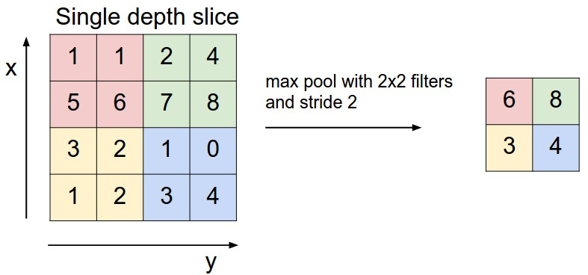

Max Pooling with 2x2 filter and stride of 2. Source: [**http://cs231n.github.io/convolutional-networks/**](http://cs231n.github.io/convolutional-networks/)

The above is an example of [**max pooling**](https://en.wikipedia.org/wiki/Convolutional_neural_network#Pooling_layer) with a 2x2 filter and stride of 2. The left square is the input and the right square is the output. The four 2x2 colors in input represents each time the filter was applied to create the max on the right side. For example, [[1, 1], [5, 6]] becomes 6 and [[3, 2], [1, 2]] becomes 3.

**def** **maxpool2d**(x, k=2):

**return** tf.nn.max_pool(

x,

ksize=[1, k, k, 1],

strides=[1, k, k, 1],

padding='SAME')

The [**tf.nn.max_pool()**](https://www.tensorflow.org/api_docs/python/tf/nn/max_pool) function does exactly what you would expect, it performs max pooling with the ksize parameter as the size of the filter.

**Model**

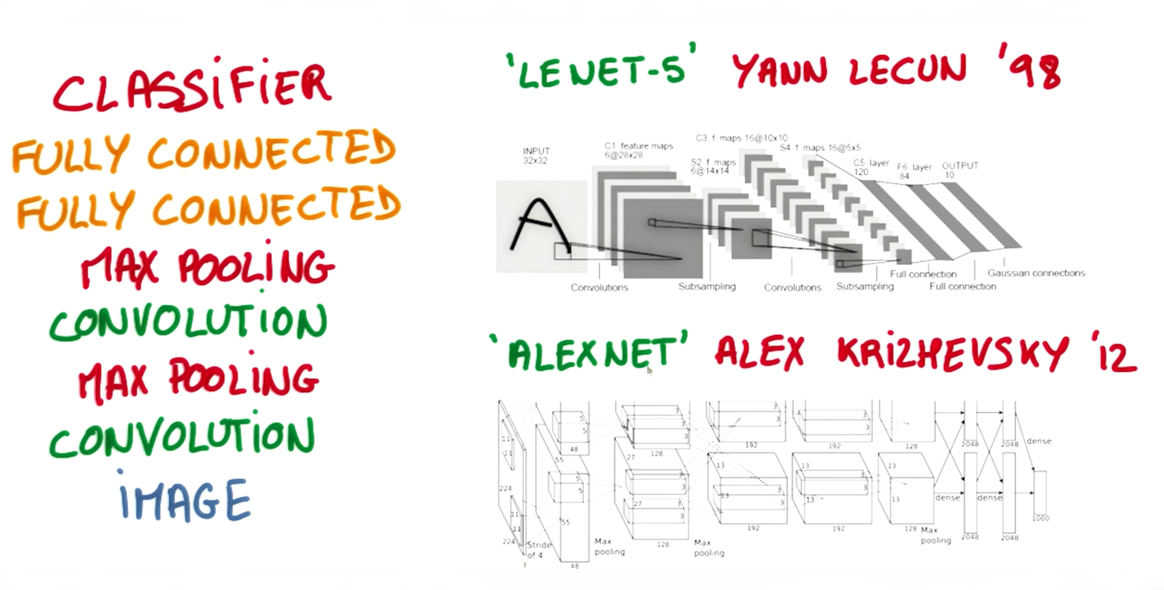

Image from Explore The Design Space video

In the code below, we're creating 3 layers alternating between convolutions and max pooling followed by a fully connected and output layer. The transformation of each layer to new dimensions are shown in the comments. For example, the first layer shapes the images from 28x28x1 to 28x28x32 in the convolution step. Then next step applies max pooling, turning each sample into 14x14x32. All the layers are applied from conv1to output, producing 10 class predictions.

**def** **conv_net**(x, weights, biases, dropout):

*# Layer 1 - 28*28*1 to 14*14*32*

conv1 = conv2d(x, weights['wc1'], biases['bc1'])

conv1 = maxpool2d(conv1, k=2)

*# Layer 2 - 14*14*32 to 7*7*64*

conv2 = conv2d(conv1, weights['wc2'], biases['bc2'])

conv2 = maxpool2d(conv2, k=2)

*# Fully connected layer - 7*7*64 to 1024*

fc1 = tf.reshape(conv2, [-1, weights['wd1'].get_shape().as_list()[0]])

fc1 = tf.add(tf.matmul(fc1, weights['wd1']), biases['bd1'])

fc1 = tf.nn.relu(fc1)

fc1 = tf.nn.dropout(fc1, dropout)

*# Output Layer - class prediction - 1024 to 10*

out = tf.add(tf.matmul(fc1, weights['out']), biases['out'])

**return** out

**Session**

Now let's run it!

*# tf Graph input*

x = tf.placeholder(tf.float32, [**None**, 28, 28, 1])

y = tf.placeholder(tf.float32, [**None**, n_classes])

keep_prob = tf.placeholder(tf.float32)

*# Model*

logits = conv_net(x, weights, biases, keep_prob)

*# Define loss and optimizer*

cost = tf.reduce_mean(\

tf.nn.softmax_cross_entropy_with_logits(logits=logits, labels=y))

optimizer = tf.train.GradientDescentOptimizer(learning_rate=learning_rate)\

.minimize(cost)

*# Accuracy*

correct_pred = tf.equal(tf.argmax(logits, 1), tf.argmax(y, 1))

accuracy = tf.reduce_mean(tf.cast(correct_pred, tf.float32))

*# Initializing the variables*

init = tf. global_variables_initializer()

*# Launch the graph*

**with** tf.Session() **as** sess:

sess.run(init)

**for** epoch **in** range(epochs):

**for** batch **in** range(mnist.train.num_examples//batch_size):

batch_x, batch_y = mnist.train.next_batch(batch_size)

sess.run(optimizer, feed_dict={

x: batch_x,

y: batch_y,

keep_prob: dropout})

*# Calculate batch loss and accuracy*

loss = sess.run(cost, feed_dict={

x: batch_x,

y: batch_y,

keep_prob: 1.})

valid_acc = sess.run(accuracy, feed_dict={

x: mnist.validation.images[:test_valid_size],

y: mnist.validation.labels[:test_valid_size],

keep_prob: 1.})

print('Epoch {:>2}, Batch {:>3} -'

'Loss: {:>10.4f} Validation Accuracy: {:.6f}'.format(

epoch + 1,

batch + 1,

loss,

valid_acc))

*# Calculate Test Accuracy*

test_acc = sess.run(accuracy, feed_dict={

x: mnist.test.images[:test_valid_size],

y: mnist.test.labels[:test_valid_size],

keep_prob: 1.})

print('Testing Accuracy: {}'.format(test_acc))

That's it! That is a CNN in TensorFlow. Now that you've seen a CNN in TensorFlow, let's see if you can apply it on your own!